**Walk 9 Fromes Hill**

Last walked in April 2017

**Description.** An 8 km (5 miles) moderate walk, but it does have a very steep hill at the end that is strenuous to climb. Lovely views as you walk down hill towards Cheyney Court Farm, and a pleasant walk along the bank of the river Frome

**Start.** Explorer Map 202 Grid 682466.

**Direction from Whitecross Roundabout** (Turn milometer to zero). Take the A4110 Canon Pyon (Three Elms road) for 1 mile and TR at the traffic lights onto the A4103 Worcester (Roman road). Continue on towards Worcester for 14.4 miles, and then turn L into Fromes Service Stations car park, (Wheatsheaf Inn on opposite side of road).

**1.** **Fromes Hill Service Station.** ***Fromes Hill is a small hamlet in Herefordshire,*** [***England***](http://en.wikipedia.org/wiki/England)***. The population is around 350, with most of the residences along the main A road or to the sides of it. The hamlet has a pub, a restaurant, an ex army store and a church.*** Walk to the main road and TR. Pass the Wheatsheaf Inn on the opposite side of the road and continue on to reach St Matthews church and TR towards Halmonds Frome. ***(St Matthews Church was founded in 1877 and is Grade II Listed).*** Continue along this road for about ¾ km to TL at a bridleway sign, (look for the mobile phone mast on your L). Pass thru the small wooden gate/large metal gate into **F1**, and walk on past the R hand side of the mobile phone mast, Staying close to the R field boundary you go thru a gate into **F2**, and continue on to go thru a metal gate into **F3** (an old small orchard), and on thru another gate into **F4**. After a short distance you go thru a way marked small wooden gate, that’s in front of you but on the R hand side, and into **F5**, a hedge is now on your L. Continue in the same direction along the L field edge and at the end of the field you go thru a large metal gate into **F6** and TR. Stay close to the hedge/fence on your R; descend slightly to the end of the field but don’t go thru the metal gate in front, cross over the stile that is in the R hand corner of the field, by the fence. Walk a few paces further on and TR, to walk along the top edge of **F7**, (the tree line/fence is on your R). Reach the R hand field corner and cross a stile into **F8** (a large stone slab is to the R). Continue on, but now the fence is on your L, to reach another stile in the L hand corner. Cross the stile, TL and descend down a track that keeps to the L hand side of the wood. At the end of the wood cross a stile into **F9** and walk down the L field edge, (ignoring any way makers or gates on your L), follow the L edge all the way round to Cheyney Court, which may not be seen until you are nearly on it.

**2. Cheyney Court.** On reaching the outskirts of Cheyney Court you bear L and cross over a very trendy stile with two rungs that lift up to enable small people to cross with ease. Walk on down the drive that’s to the L of the recently modernised Cheyney Court to reach a narrow road, TR. Walk along the narrow road to reach a T-junction and TL onto a wider road. Walk on down this road to pass the old mill on your R, also recently modernised. About 100m past the mill you cross over the river bridge, a few paces further on you TL over a stile into **F10**. Keeping the river on your L continue to the end of the field and go thru gaps in the hedge onto a road and TL. Walk a short distance and TR by a Public Footpath sign to go thru a metal gate into **F11** (ignoring the fist set of metal gates on your R). TL and continue to follow the river on your L, thru two fields **(F11/F12)** to cross a stile/metal gate onto a road. Cross the road and a stile into a huge field **F13**, follow the river Frome, which is on your L, for a good 1¾ km. On reaching the L field corner you continue on along an enclosed grassy track for a short distance to reach a Public Footpath signpost where you TL and cross over a river bridge. ***The River Frome flows thru Bromyard and Bishops Frome, and at Covender its tributary, the River Lodon, joins it. It then flows west, past Yarkhill, Prior's Frome, before its confluence with the River Lugg at Hampton Bishop. The river also gives its name to several hamlets on the higher ground to the east: Halmond's Frome, Fromes Hill and Castle Frome.*** Walk along the wide enclosed farm track to a road where you TL.

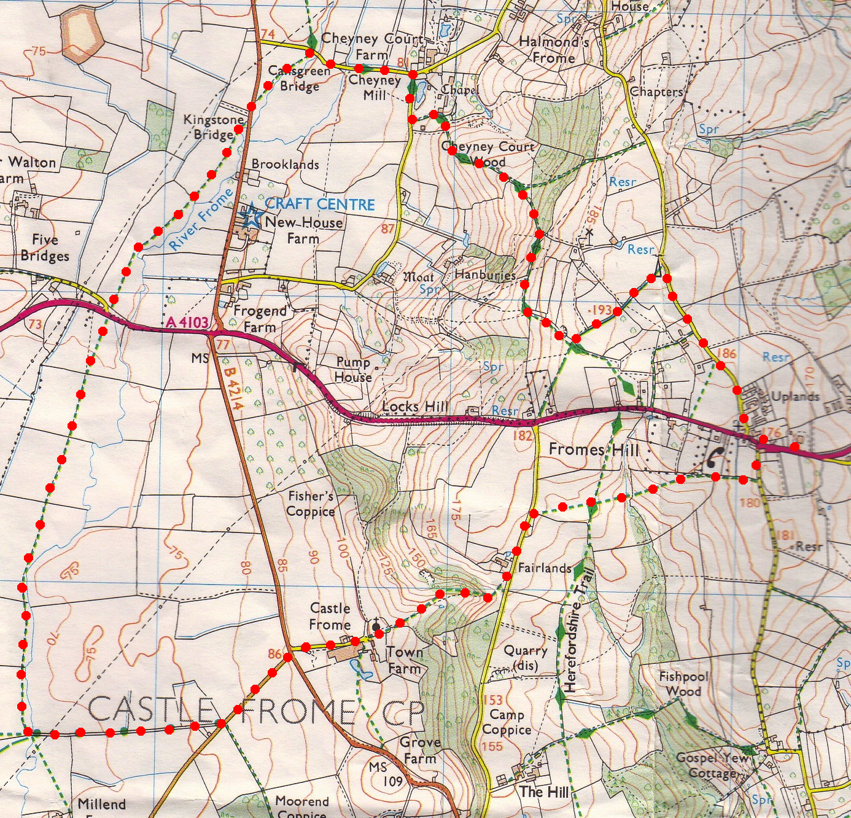**3. Road and track junction.** Walk along the road to reach a T-junction. TL and immediately TR up a No Thru Road to St Michael and All Angels Church. ***The little church of St Michael and All Angels near Castle Frome is to be found at the end of a farm track well away from the village. Originally it would have been in the village centre, but it is probable that this earlier village was evacuated at the time of the Black Death in 1348.*** Go thru the metal gates into the churchyard and follow the tarmac path as it goes to the R of the church and up to a wooden kissing gate. Go thru the gate and over a stile that’s ahead, into open country. Bear slightly L and head on uphill to walk along the gully that runs between the two woods. When you get near the top you head for the R hand side of a house, to cross over a stile. TR and walk a few paces to go thru a small wooden gate onto a road, where you TL. Continue along this road and just past a house on your R, TR thru a metal gate and into **F14**. Keep to the hedge on you R, and when it turns sharp R, you bear half L, to cross the field, going down the hill towards another way marked post that’s near the gully. Go across the gully via some steps, and then go over a stile into **F15**. Bear slightly L as you continue up hill to reach a garden hedge. Continue along the garden hedge that is on your L to go over a stile onto a road where you TL. Continue along this road to the T-junction and the car park is across the Hereford to Worcester road and off to the R.

**3**

**2**

**1**